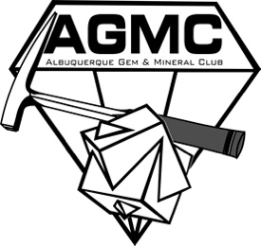 | Albuquerque  Gem & Mineral Club  Membership Form

Please include all the names to be included in your Household Membership as this is required annually for insurance purposes. Please make checks and money orders out to AGMC or Albuquerque Gem & Mineral Club

Annual dues are $30.00 per household. New members joining after July 1st pay dues of $15.00 for the rest of the year. All memberships expire midnight December 31st. All household members must reside at the same address. Only 2 Adult members per family. All junior members MUST be under 18. Additional adults must have their own membership.

Dues can be turned in at the monthly meeting or mailed to:
Albuquerque Gem & Mineral Club, PO Box 13718, Albuquerque, NM 87192-3718

The requirements for attending field trips were changed at the December 6, 2021 Board meeting.
If you are inviting family and friends to join the AGMC and they are planning on going on a field trip, their dues and membership application MUST be in by the 1st of that month.
If their membership application and dues are not in by the 1st or before, they will not be permitted to attend that month’s trip. Dues WILL NOT be accepted at the field trip.
Please complete all the information below. All membership information is for Club use only.

Last Name: |  |  |  |  |  |  |  |  |  | Date:
Adult Member Names 1.
2.
Junior Member Names 1. |  |  |  |  |  |  |  |  |  |  |  |  | Age:
2. |  |  |  |  |  |  |  |  |  |  |  |  | Age:
3. |  |  |  |  |  |  |  |  |  |  |  |  | Age:
4. |  |  |  |  |  |  |  |  |  |  |  |  | Age:
Mailing Address: |  |  |  |  |  |  |  |  |  |  |  |  | Apt. #:
City: |  |  |  |  |  |  |  | State: |  |  | Zip
Phone:
Email Address:
All newsletters will be sent electronically to the above email.
(please check one below)
☐ New Member - joining between (Jan 1 – Jun 30) - $30
☐ New Member - joining between (Jul 1 – Dec 31) - $15
☐ Existing Member Renewal - $30

Internal Use Only

Payment $: |  | Date Received: |  |  | Date of Check:
☐ Cash | ☐ Ck #: |  | ☐ Money Order #:

Revised 11/2022

